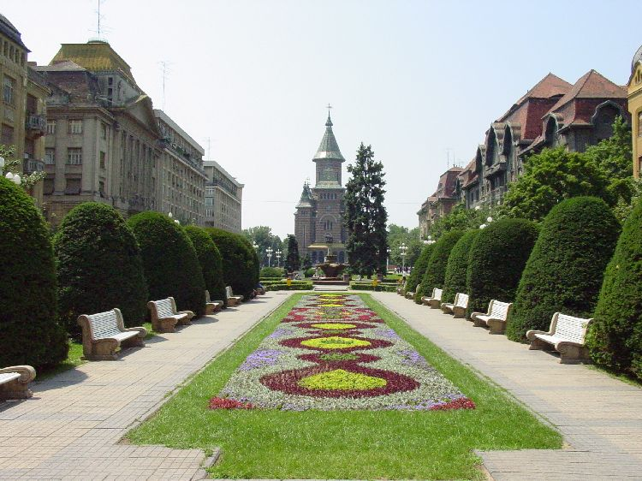

International Workshop on the Risk Stratification in Patients with Ischemic Heart disease

Workshop organized by the Cardiology Clinic of the Emergency County Hospital Timisoara, Romania
under the patronage of the International Society for Holter and Noninvasive Electrocardiology (ISHNE)

Adam Müller-Guttenbrunn House

Timisoara, Romania

12-13.04.2007
LOCAL ORGANIZING COMMITTEE

President:

Rodica Avram MD, PhD
Organizer:
Victor Dan Moga MD, PhD
moga.victor@gmail.com
Viviana Ivan MD, PhD
ivanmvivi@yahoo.com
Secretary:
Tudor Ciocârlie MD
timisoara2007@yahoo.com
Congress Master:
Ioan Cuculescu MD
congress@zappmobile.ro
Members:
Adrian Apostol MD
Mihai Balint MD
Lucian Bosneag Eng.
Livia Brânzan MD, PhD
Oana Ciocârlie MD
Mariana Moga Eng.

Miroslav Nicolin MD

Florina Pârv MD

Doina Rosu MD, PhD
Mariana Tudoran MD, PhD

Marius Ţurcan MD, PhD

SCIENTIFIC COMMITTEE

Honorary President: Wojciech Zareba (USA)
Shlomo Stern (Israel)

President: Rodica Avram (Timisoara)
Dan Dominic Ionescu (Craiova)

Members: Juan Cinca (Spain)
Eran Toledo (Israel)
Leonid Makarov (Russia)
Ungi Imre (Hungary)
Jecu Avram (Timisoara)
Gheorghe Mihalaş (Timisoara)
Lăcrămioara Stoicu-Tivadar (Timisoara)
Vasile Stoicu-Tivadar (Timisoara)

MAIN TOPICS
Heart Rate Variability
ECG in Acute Myocardial Infarction
Heart Rate Turbulence
Noninvasive Risk Stratification
Signal – Averaged ECG
T Wave Alternans and Variability
QT Dispersion and Safety Pharmacology

LOCATION: Adam Müller-Guttenbrunn House, Timişoara.
There will also be an Exhibition Area for Pharmaceutical Industry.

OFFICIAL LANGUAGE: English

REGISTRATION: www.hosptm.ro/evenimente Please send the completed form to timisoara2007@yahoo.com
PRELIMINARY PROGRAMME

Thursday 12.04.2007
Opening Ceremony

Free Lectures

- Heart Rate Variability

- Coffee break -

- ECG in Acute Myocardial Infarction

- Lunch break -

- Heart Rate Turbulence

- Noninvasive Risk Stratification

Welcome party - cocktail -

Friday 13.04.2006

Free Lectures

- Signal – Averaged ECG

- Coffee break -

- T Wave Alternans and Variability

- Lunch break -

- QT Dispersion and Safety Pharmacology

- Conclusions

Gala dinner - cocktail -

ABSTRACT

Abstract Title - Times New Roman, size 16 font, bold, left aligned, initial capitals
Authors - Times New Roman, size 12 fonts, Surname, Initials Presenting Author to be bold
Affiliations - Times New Roman, size 12 font, Italics, Affiliation, City, and Country
Abstract text - Times New Roman, size 12 font, left aligned, maximum 250 words
Save the abstract as a Microsoft Word document (*.DOC).

Send abstracts to this email address: timisoara2007@yahoo.com .
Deadline for abstract submission:
The 5th of March 2007.

Notification of acceptance of abstracts
The 20th of March 2007.

The papers will be presented in MS Office, PowerPoint on Windows XP.

PARTICIPATON FEE

Early fee (before March 12th, 2007) 30 EUR (100 RON)
Late fee (after March 12th, 2007) 50 EUR (170 RON)
Specialists in training – 50% discount
Accompanying persons – 50% discount

The fees should be paid to:
“Fundatia Cardioprogress” Timisoara,
Fiscal code: LI 15396990
Cont RON: RO03 BRDE 360S V128 5800 3600
Cont EURO: RO63 BRDE 360S V443 5658 3600
BRD Groupe Societe Generale, Sucursala Timisoara
Continental Hotel****
300054 B-dul Revoluţiei 1989 nr. 5
Tel.: +40-256-494.144 Fax: +40-256-494.145
E-mail: agentie@hotelcontinental.ro, Web site: www.hotelcontinental.ro
Room price: 65-70 Euro

Timisoara Hotel***
300086 Str. Mărăşeşti 1-3
Tel.: +40-256-498.854 • 498.856 Fax: +40-256-499.450
E-mail: receptie@hoteltimisoara.ro, Web site: www.hoteltimisoara.ro
Room price: 42-52 Euro

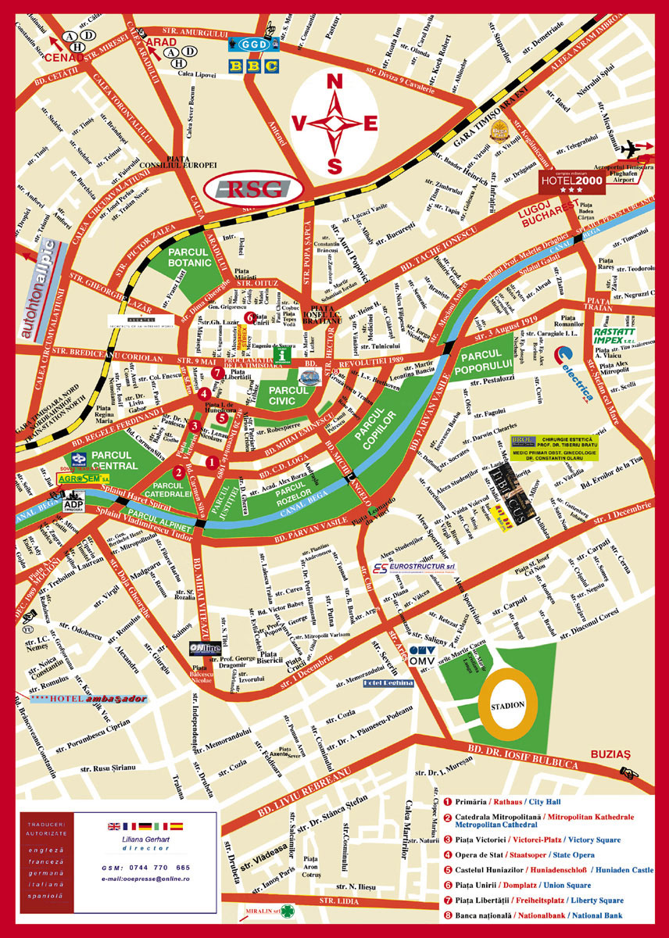

"The City of Flowers", "The Paradise of Parks", "The Small Vienna" is only few of the names that made famous the city on the banks of the river Bega. With a population of over 330,000 inhabitants Timisoara, one of the largest and most important cities in Romania, is a multiethnic city, of traditions and culture, defined by the harmoniously living together of Romanians, Hungarians, Germans, Serbians, Croats, Bulgarians and Romanies, each of them keeping their traditions and culture. One of the 4 well-developed university centre of the country, Timisoara also represents an important polarizing centre for romanian and foreign tourists and business people due to its geopolitical position, the properly trained human resources, the developed material support, and not least the interethnic and inter-religious harmony.
Symbol of Timisoara "Lupoaica" (the wolf), the statue of Romulus and Remus - located in the city centre is the copy of the famous "Lupa Capitolina" in Rome. Also the "House with the Iron Tree" or the "Tree of Guilds", a body of a tree surrounded by an ironed belt that has been driven with ironed nails during several centuries by the skilled workers who crossed Timisoara after they have returned from the "training" journeys made in different cities of Europe.
Other places worth to be visited are: the Victories Square (the Statue of the Wolf, the Metropolitan Cathedral, the Romanian Opera), the Unirii Square (the Catholic Dome, the Baroque Palace, the Fountain with Mineral Water, the Saint Trinity Monument), the Libertatii Square (the Military Casino, the Old Town Hall, the Statue of Decebal Dacian King, the St. Nepomuk Statue), the Maria Square (the Statue of the Virgin), the Huniade Castle - today the Museum of Banat, the Dicasterial Palace, the "Cardinal Points" Fountain, the Decebal Bridge, the Serbian Orthodox Church, the Synagogue.

